**Solution of Assignment-4**

import pandas as pd

import matplotlib.pyplot as plt

data = pd.read_csv('company_sales_data.csv')

# Task 1: Read Total profit of all months and show it using a line plot

plt.figure(figsize=(2,2))

plt.plot(data['month_number'], data['total_profit'], marker='o', linestyle='-', color='b')

plt.xlabel('Month Number')

plt.ylabel('Total profit')

plt.title('Profit of All Months')

plt.grid(True)

plt.show()

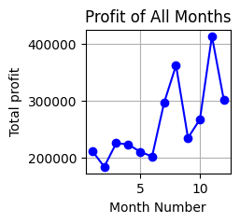

plt.figure(figsize=(5, 3))  # Adjust figure size as needed

plt.plot(data['month_number'], data['total_profit'], marker='o', linestyle='-', color='b')

plt.xlabel('Month Number')

plt.ylabel('Sold units number')  # Using 'Sold units number' as per your request

plt.title('Profit of All Months')

plt.grid(True)

plt.show()

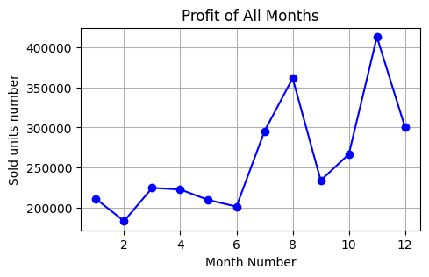

# Task 3: Read all product sales data and show it using a multiline plot

plt.figure(figsize=(3,6))

plt.plot(data['month_number'], data['facecream'], label='Face Cream', marker='o')

plt.plot(data['month_number'], data['facewash'], label='Face Wash', marker='o')

plt.plot(data['month_number'], data['toothpaste'], label='Toothpaste', marker='o')

plt.plot(data['month_number'], data['bathingsoap'], label='Bathing Soap', marker='o')

plt.plot(data['month_number'], data['shampoo'], label='Shampoo', marker='o')

plt.plot(data['month_number'], data['moisturizer'], label='Moisturizer', marker='o')

plt.xlabel('Month Number')

plt.ylabel('Sales units in number')

plt.title('Sales Data of All Products')

plt.legend()

plt.grid(True)

plt.show()

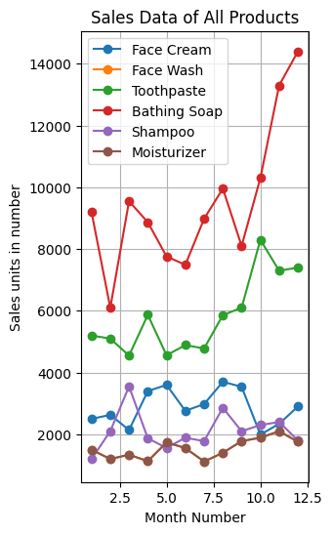

#4

toothpaste_sales = data[['month_number', 'toothpaste']]

# Create scatter plot

plt.figure(figsize=(5, 3))

plt.scatter(toothpaste_sales['month_number'], toothpaste_sales['toothpaste'], s=80, color='green', marker='o')

plt.xlabel('Month Number')

plt.ylabel('Toothpaste Sales')

plt.title('Toothpaste Sales Data')

plt.grid(True)

plt.show()

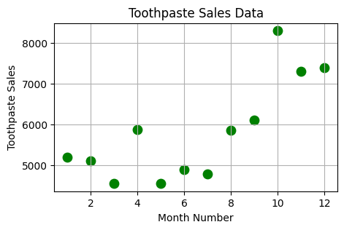

# Task 5: Read face cream and facewash product sales data and show it using the bar chart

plt.figure(figsize=(3,4))

bar_width = 0.4

plt.bar(data['month_number'] - bar_width/2, data['facecream'], width=bar_width, label='Face Cream', color='blue')

plt.bar(data['month_number'] + bar_width/2, data['facewash'], width=bar_width, label='Face Wash', color='orange')

plt.xlabel('Month Number')

plt.ylabel('Sales units in number')

plt.title('Face Cream and Face Wash Sales Data')

plt.legend()

plt.grid(True)

plt.show()

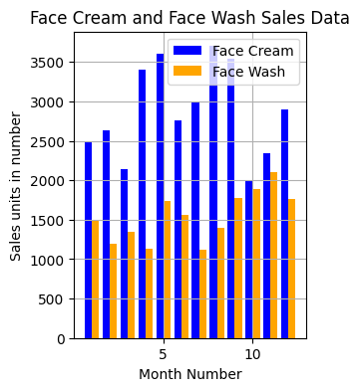

# Task 6: Read sales data of bathing soap of all months and show it using a bar chart

plt.figure(figsize=(3,4))

plt.bar(data['month_number'], data['bathingsoap'], color='purple')

plt.xlabel('Month Number')

plt.ylabel('Bathing Soap Sales')

plt.title('Bathing Soap Sales Data')

plt.grid(True)

plt.show()

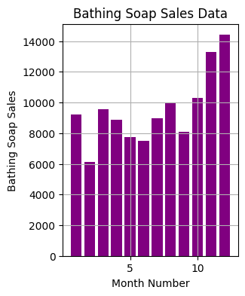

# Task 7a: Histogram to see the most common profit ranges

plt.figure(figsize=(10,6))

plt.hist(data['total_profit'], bins=10, color='orange')

plt.xlabel('Profit Ranges')

plt.ylabel('Frequency')

plt.title('Profit Range Histogram')

plt.grid(True)

plt.show()

# Task 7b: BarChart to see the most common profit ranges

profit_ranges = pd.cut(data['total_profit'], bins=10).value_counts().sort_index()

plt.figure(figsize=(10,6))

profit_ranges.plot(kind='bar', color='red')

plt.xlabel('Profit Ranges')

plt.ylabel('Frequency')

plt.title('Profit Range Bar Chart')

plt.grid(True)

plt.show()

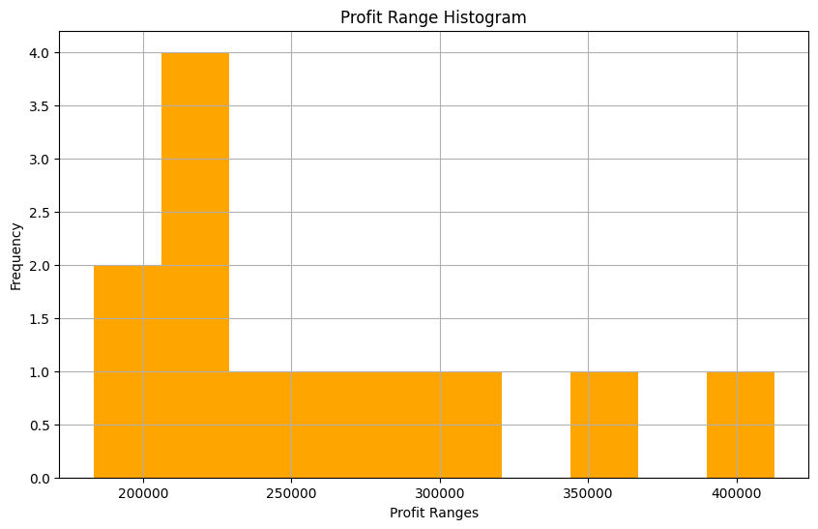 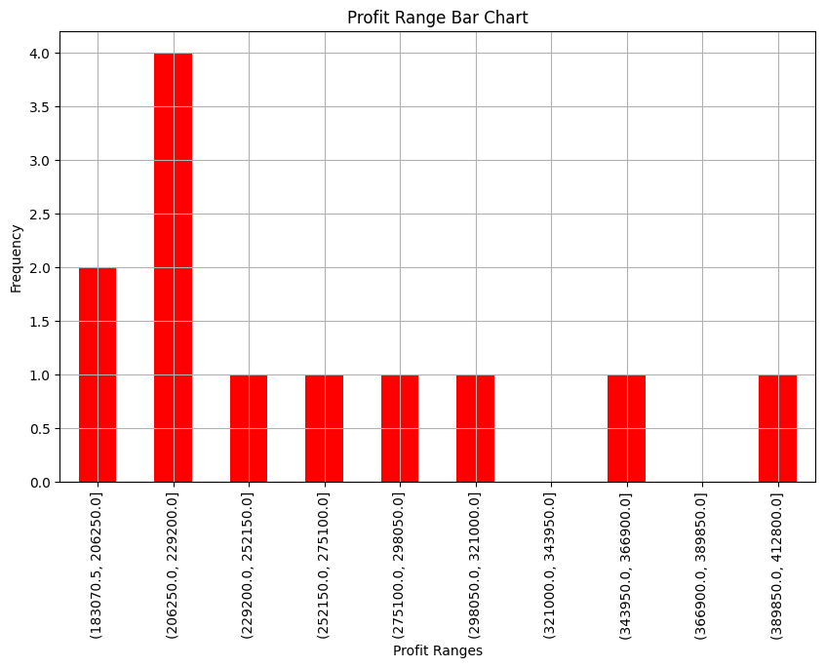

# Task 8: Calculate total sale data for last year for each product and show it using a Pie chart

total_sales = data[['facecream', 'facewash', 'toothpaste', 'bathingsoap', 'shampoo', 'moisturizer']].sum()

plt.figure(figsize=(4,4))

total_sales.plot(kind='pie', autopct='%1.1f%%', startangle=140)

plt.title('Total Sales Data for Last Year')

plt.ylabel('')

plt.show()

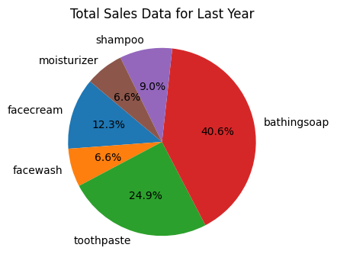

# Task 9: Read Bathing soap and facewash of all months and display it using the Subplot

plt.figure(figsize=(14,6))

plt.subplot(1, 2, 1)

plt.plot(data['month_number'], data['bathingsoap'], label='Bathing Soap', marker='o')

plt.xlabel('Month Number')

plt.ylabel('Sales units in number')

plt.title('Bathing Soap Sales Data')

plt.legend()

plt.grid(True)

plt.subplot(1, 2, 2)

plt.plot(data['month_number'], data['facewash'], label='Face Wash', color='g', marker='o')

plt.xlabel('Month Number')

plt.ylabel('Sales units in number')

plt.title('Face Wash Sales Data')

plt.legend()

plt.grid(True)

plt.tight_layout()

plt.show()

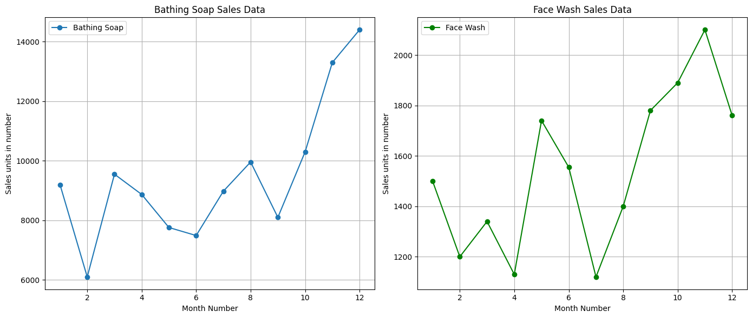

# Task 10: Read all product sales data and show it using the Bar Graph

plt.figure(figsize=(5,8))

bar_width = 0.1

months = data['month_number']

plt.bar(months - 3*bar_width, data['facecream'], width=bar_width, label='Face Cream')

plt.bar(months - 2*bar_width, data['facewash'], width=bar_width, label='Face Wash')

plt.bar(months - bar_width, data['toothpaste'], width=bar_width, label='Toothpaste')

plt.bar(months, data['bathingsoap'], width=bar_width, label='Bathing Soap')

plt.bar(months + bar_width, data['shampoo'], width=bar_width, label='Shampoo')

plt.bar(months + 2*bar_width, data['moisturizer'], width=bar_width, label='Moisturizer')

plt.xlabel('Month Number')

plt.ylabel('Sales units in number')

plt.title('Sales Data of All Products')

plt.legend()

plt.grid(True)

plt.show()

